Creating Reports with the REPORT Procedure (Self-Study)

19.1 Creating Reports with the REPORTS Procedure 19-3
Exercises 19-17
19.2 Solutions 19-18
Solutions to Exercises 19-18

Creating Reports with the REPORTS Procedure

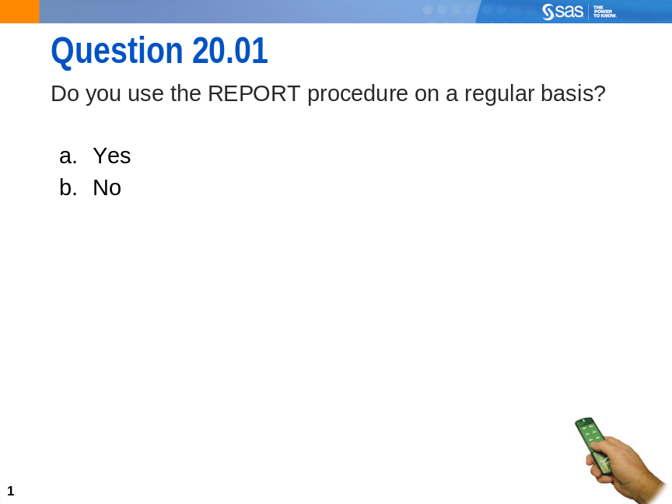
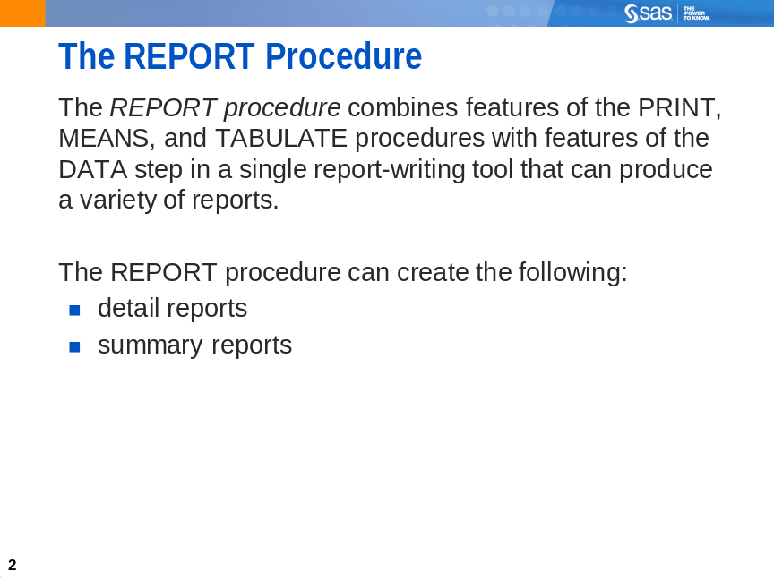
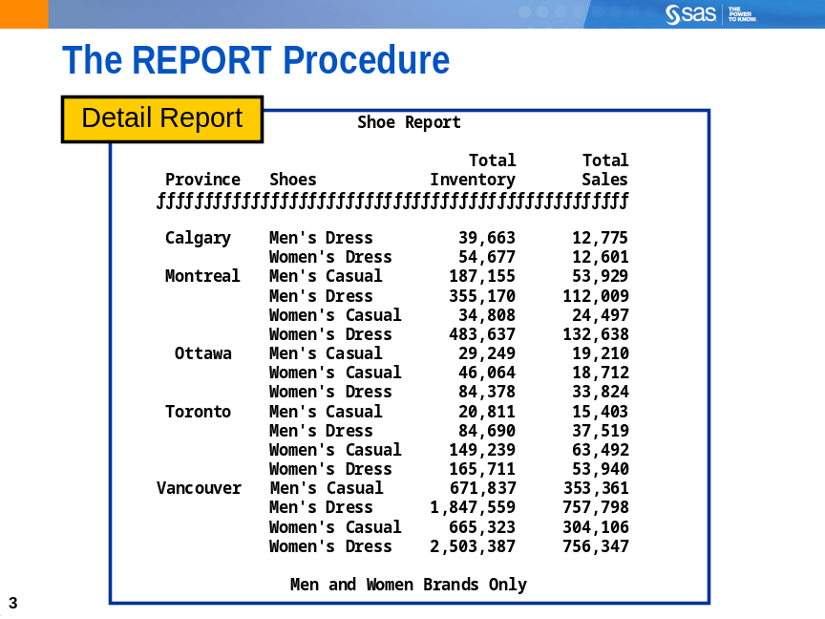
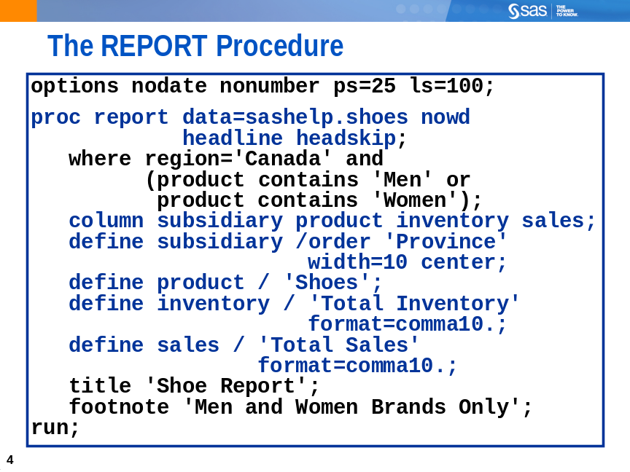
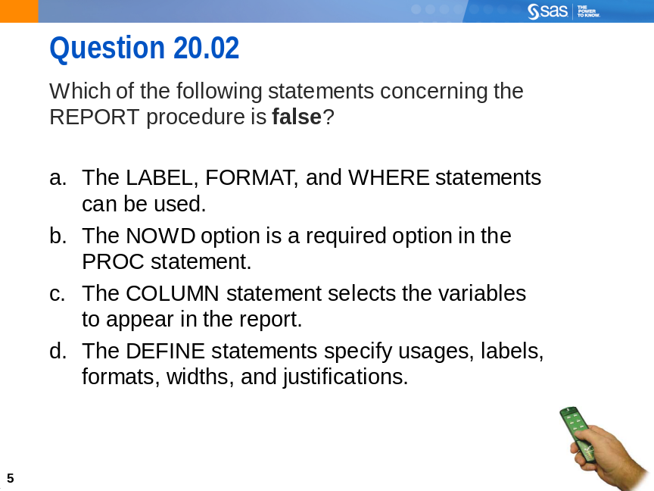
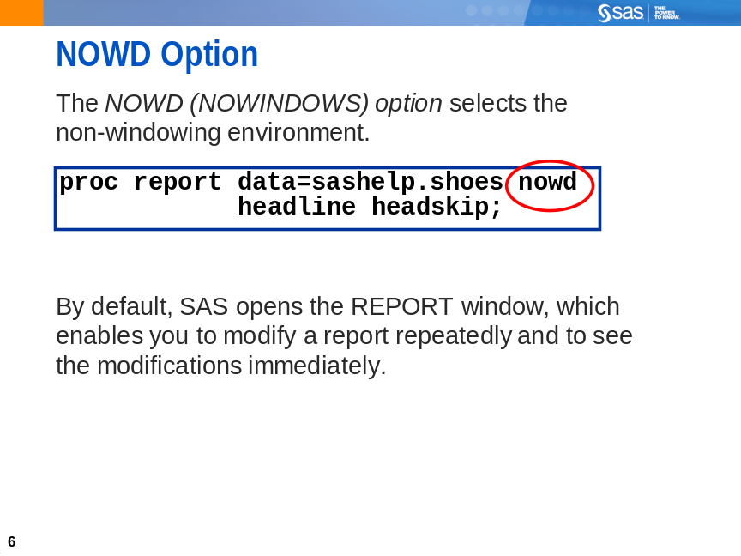
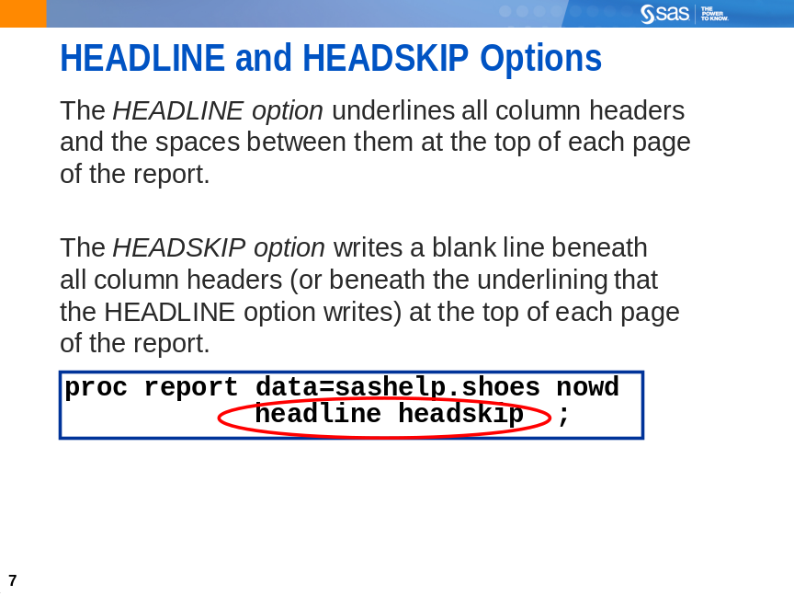
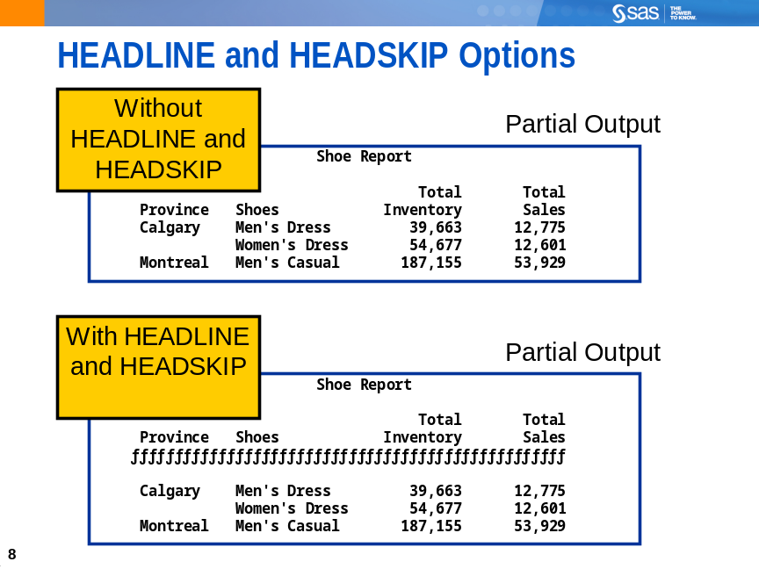
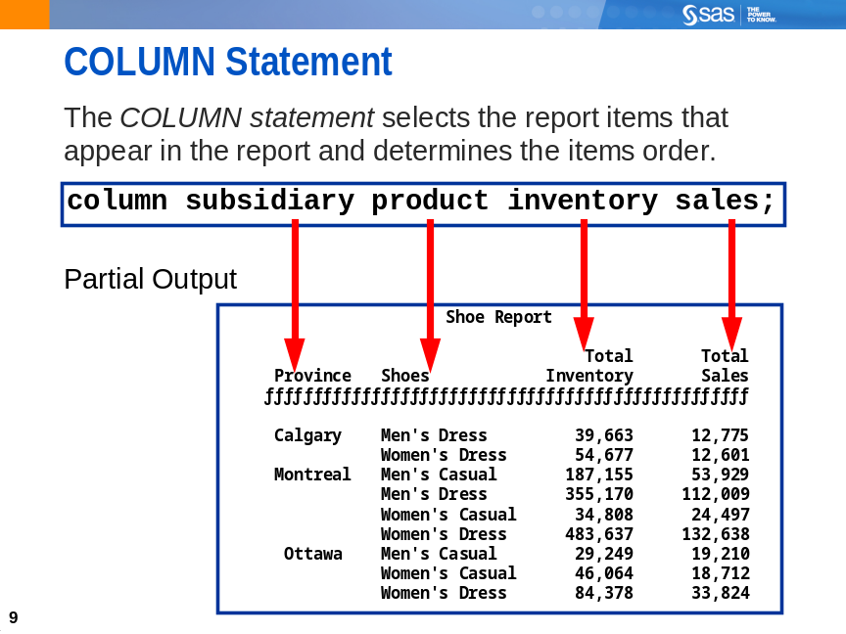
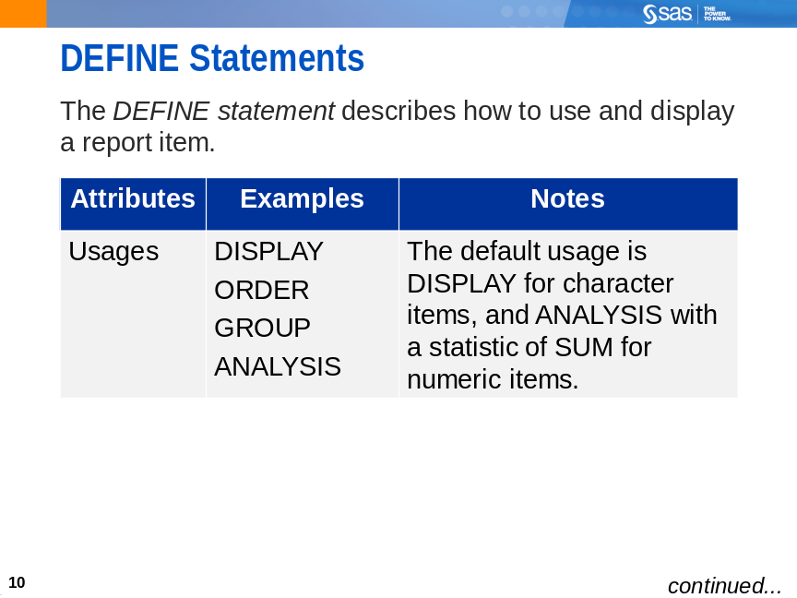
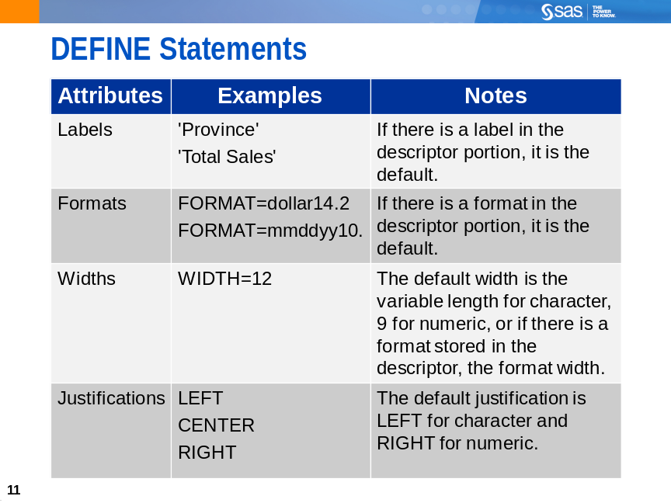
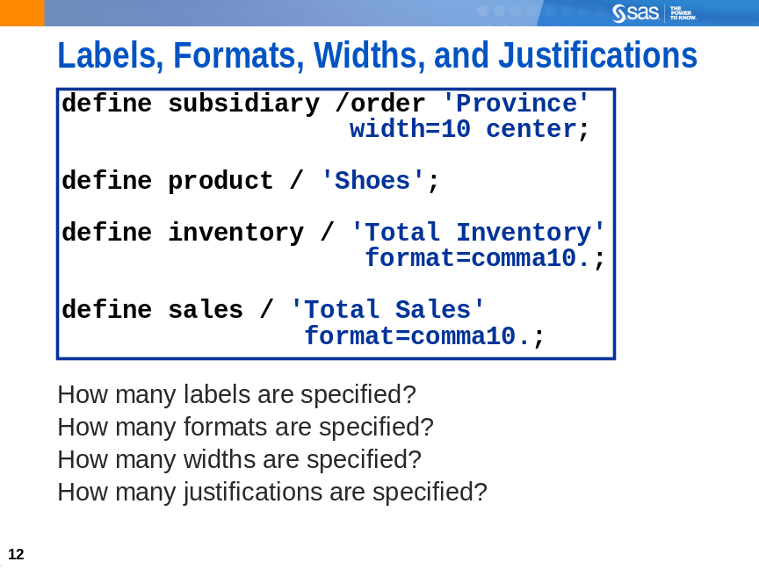
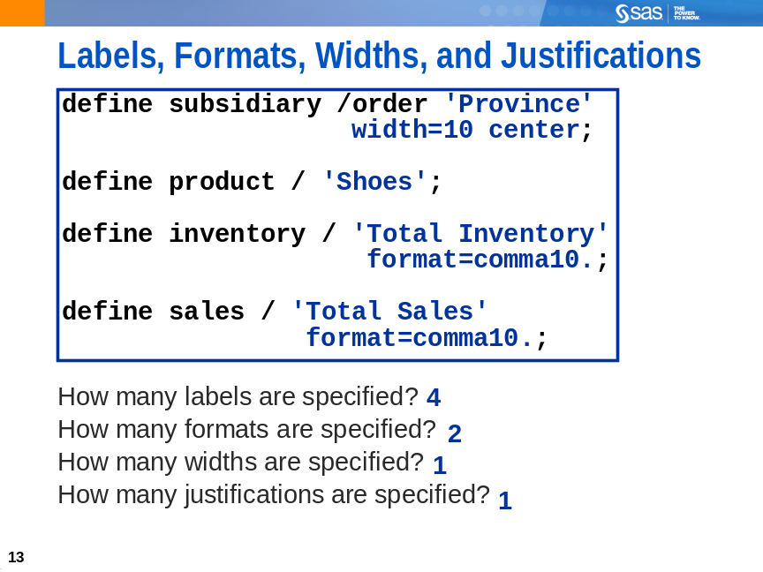
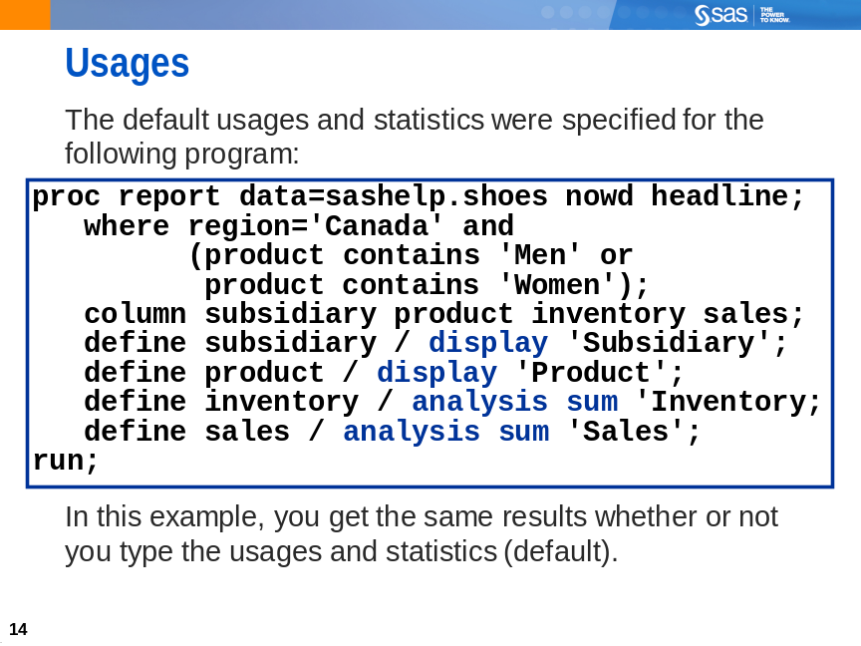
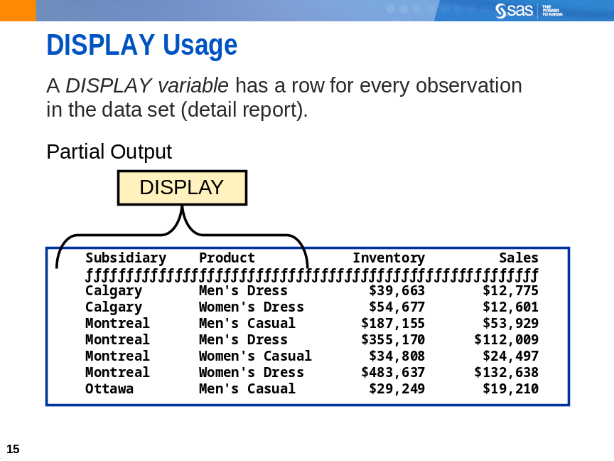
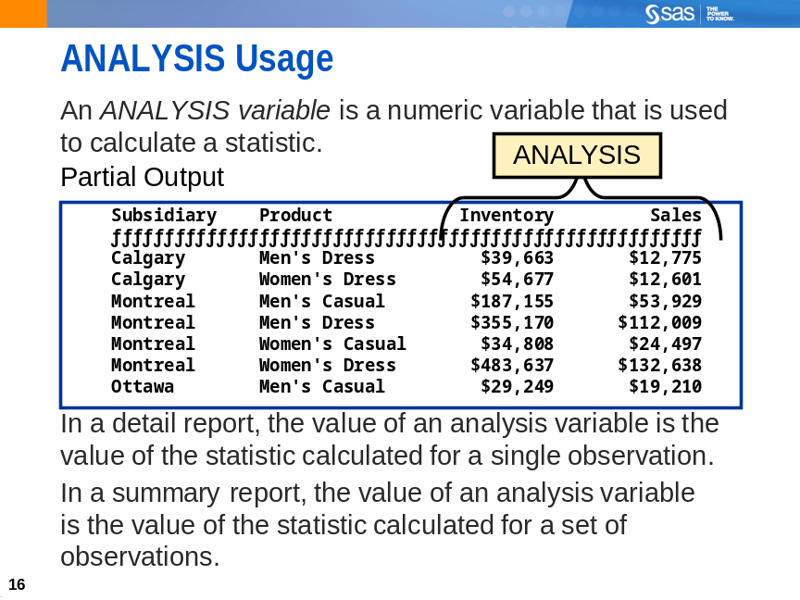
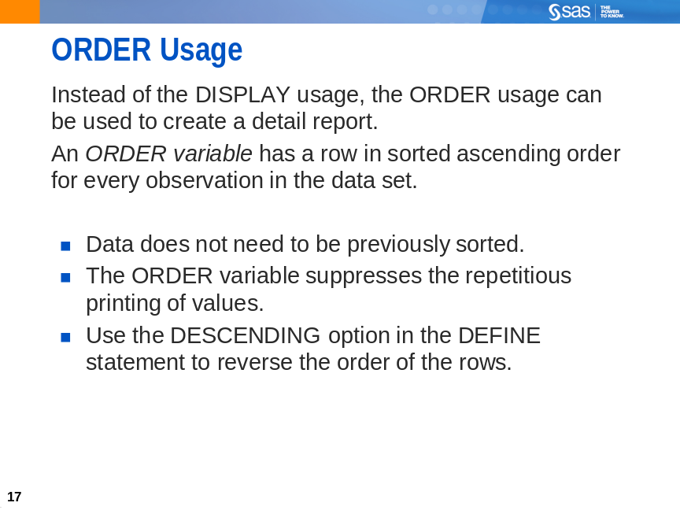
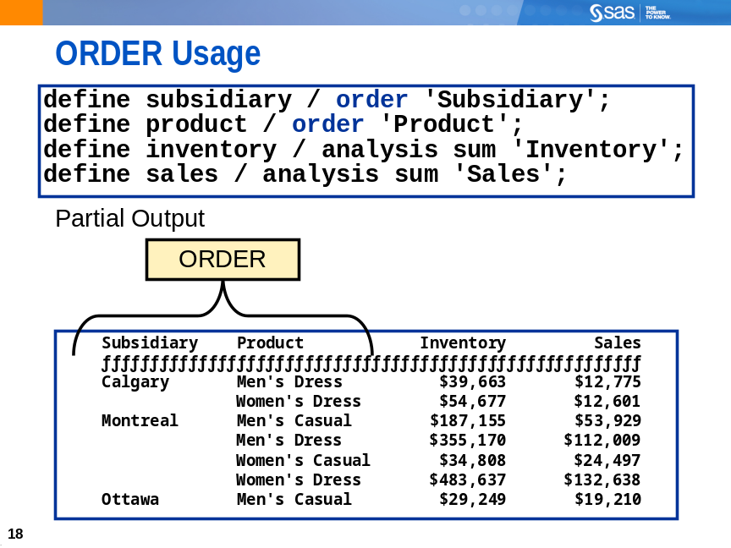
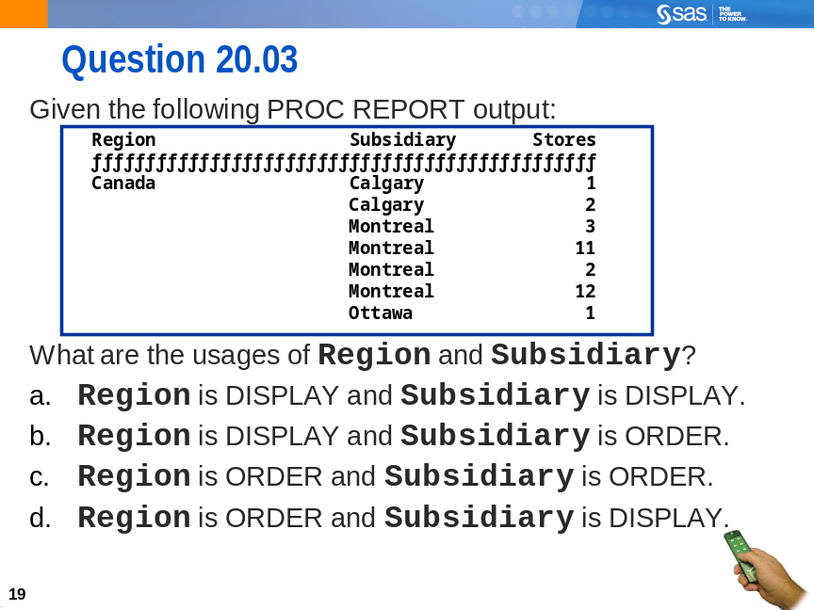

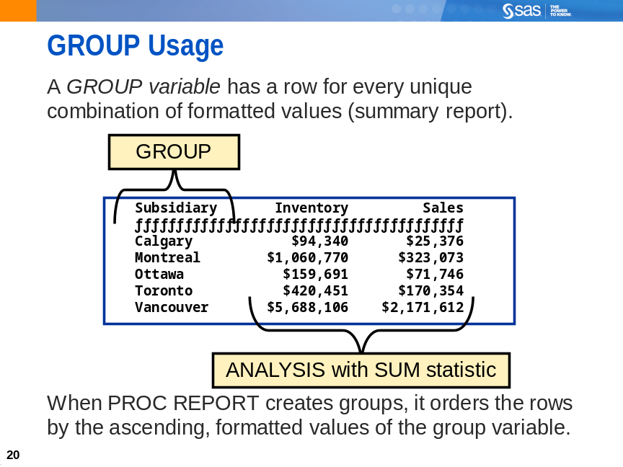
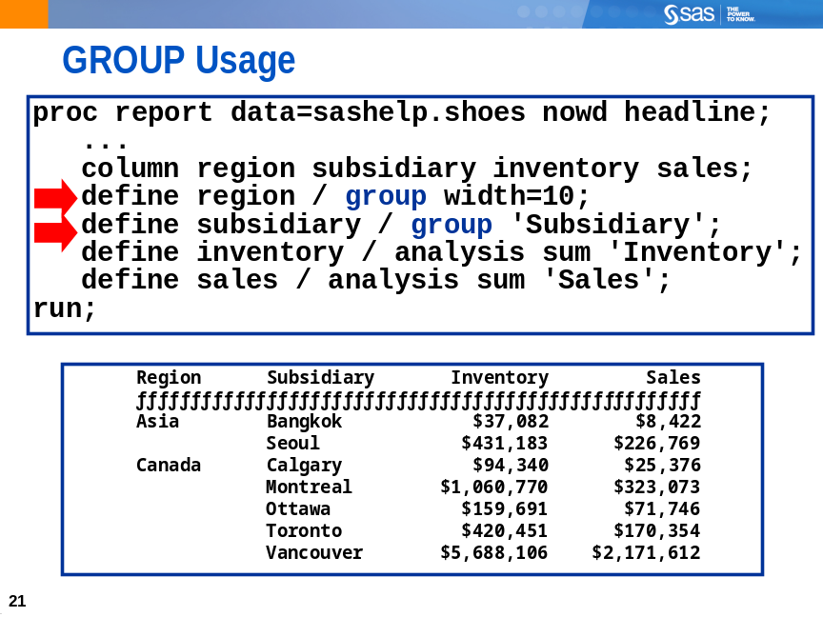
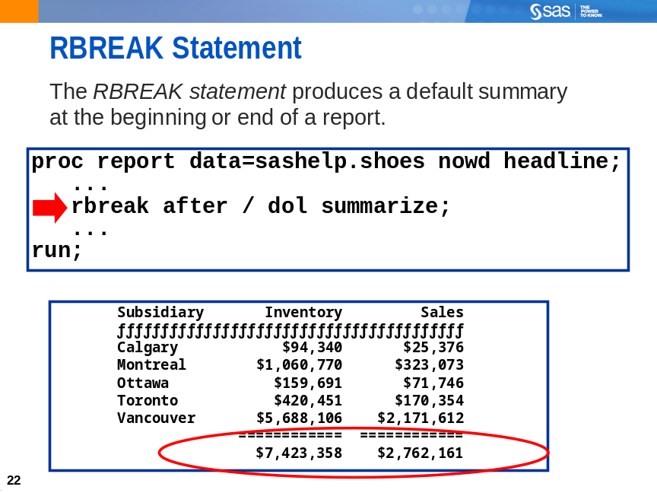
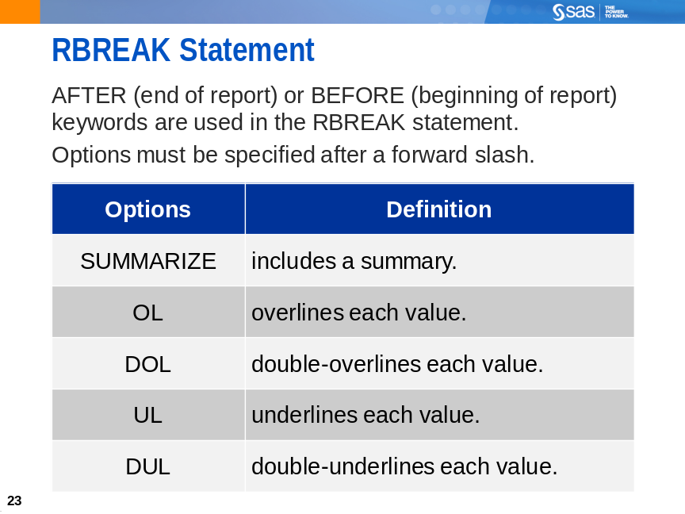
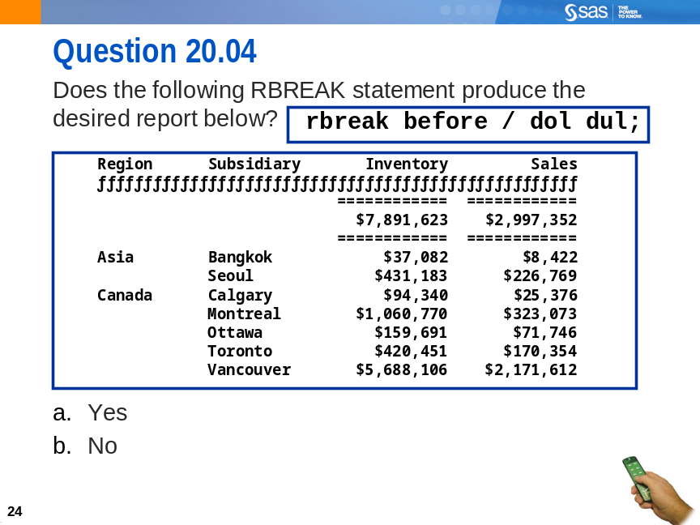

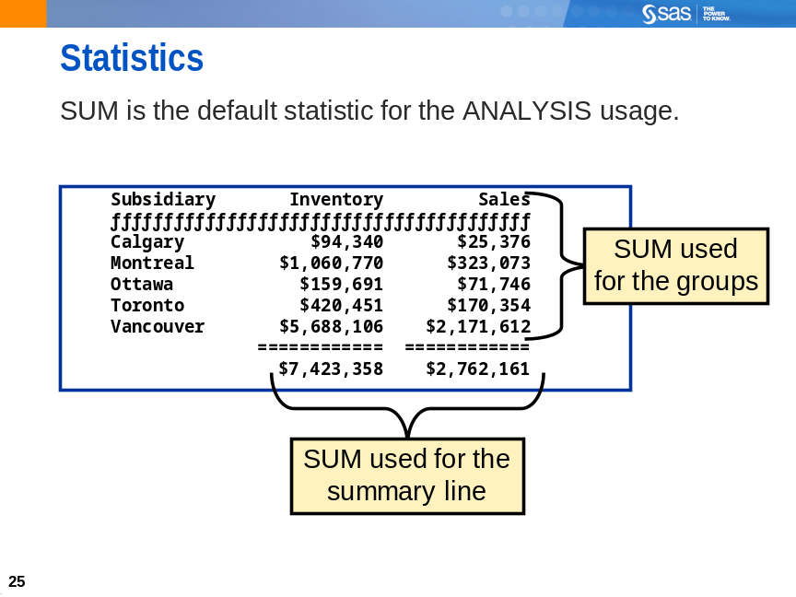
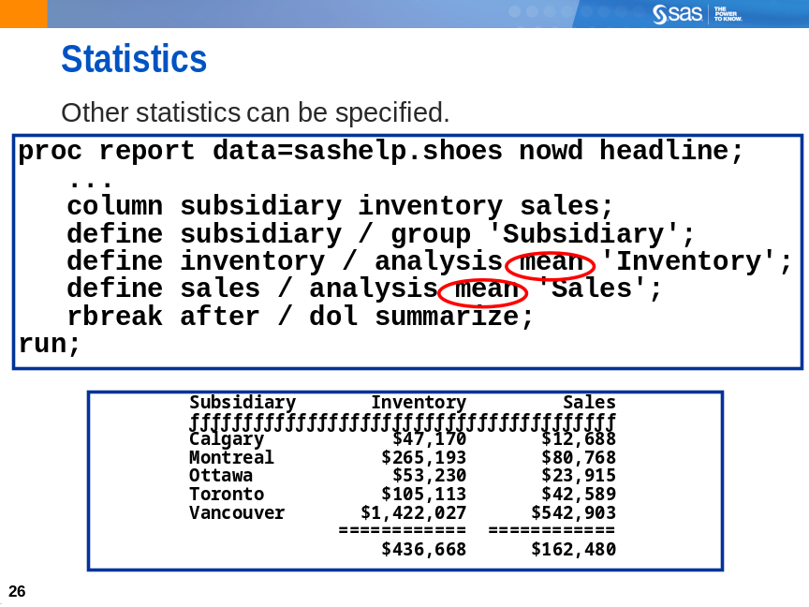
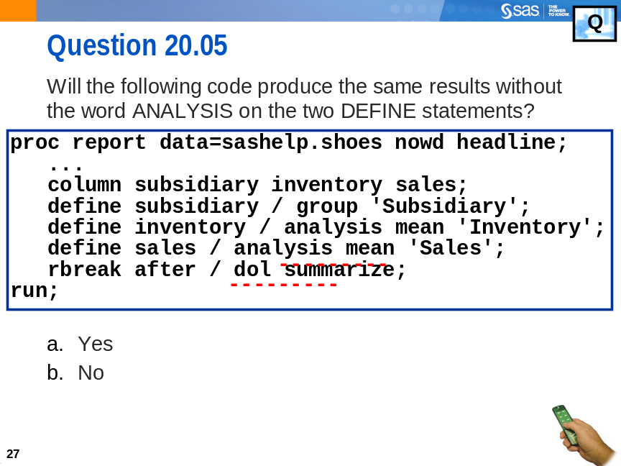


Exercises

Level 1
1. The REPORT Procedure
The following is the desired report:
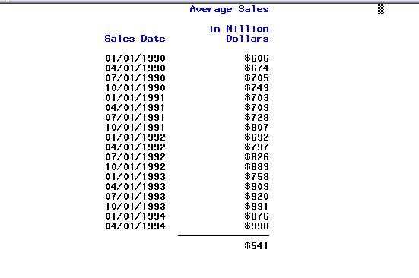

Open the program file c20e01.sas (see code shown below) and correct it to create the desired report:
options nodate nonumber ps=25 ls=64;
proc report data=sashelp.retail nowd headline headskip;
column date sales;
define date / format=mmddyy10. 'Sales Date';
define sales / mean 'Average Sales in Million Dollars'
format=dollar6. width=15;
rbreak after / ol;
title;
run;
Hint: One word must be deleted and two words must be added.

Solutions

Solutions to Exercises

- The REPORT Procedure

HEADLINE must be deleted and DISPLAY and SUMMARIZE must be added.

options nodate nonumber ps=25 ls=64;
proc report data=sashelp.retail nowd headline headskip;
column date sales;
define date / display format=mmddyy10.
'Sales Date';
define sales / mean 'Average Sales
in Million Dollars'
format=dollar6. width=15;
rbreak after / ol summarize;
title;
run;

